The E-Learning Operation Manual

Dear examinees:
The preliminary contest of Middle East Huawei ICT Skill Competition will be conducted on Huawei's e-learning platform.
In order to facilitate you to get familiar with the test system and check the equipment situation, we recommend that you enter the system in advance and do simulation test.

- Enter in the E-learning website: http://e-learning.huawei.com/exam/

- You will receive an e-mail from HWSSO@huawei.com. In this E-mail, you will get your account and your password. Please note to check! (We will use your email address registered in the ICT Academy Platform to send you account and password)

- If you have already registered in www.huawei.com, please log in with your own account and password.
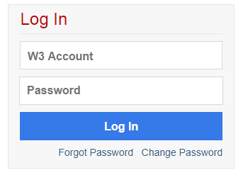
- Click the ‘Take exam’ button

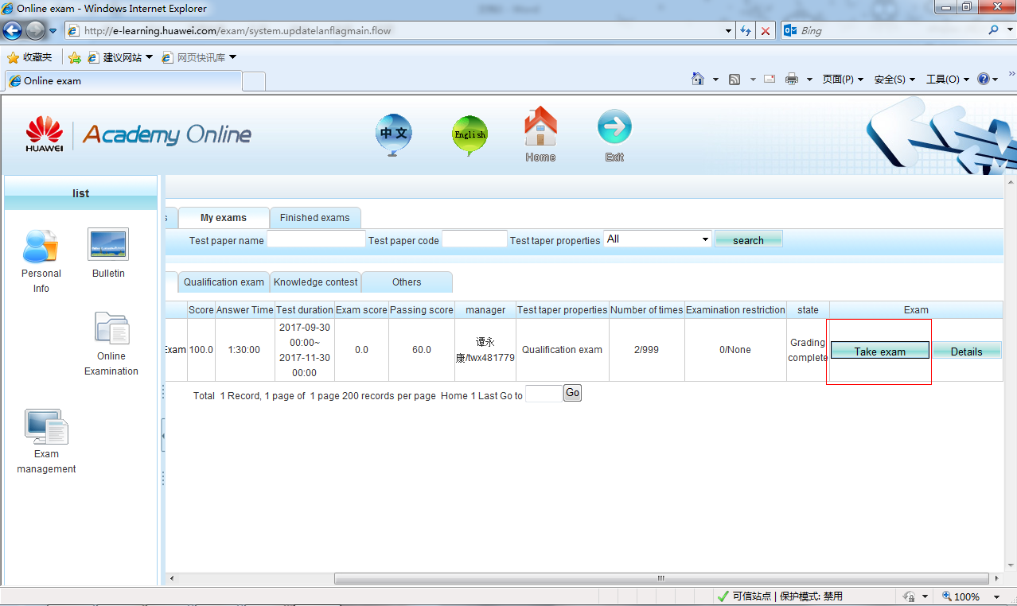

- Read the Notes and click the ‘red arrow ’ button

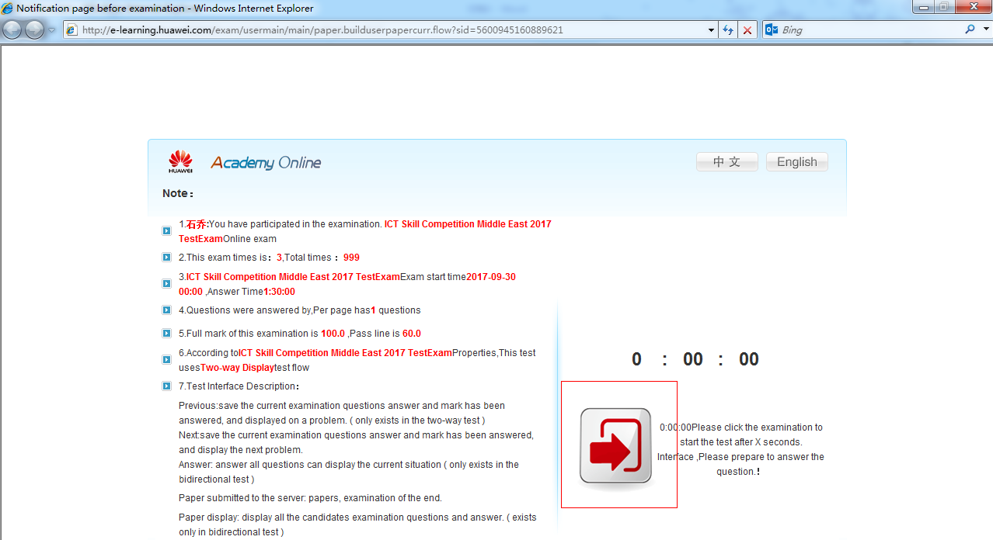

- Finish the exam question. Click the ‘Submit’ button
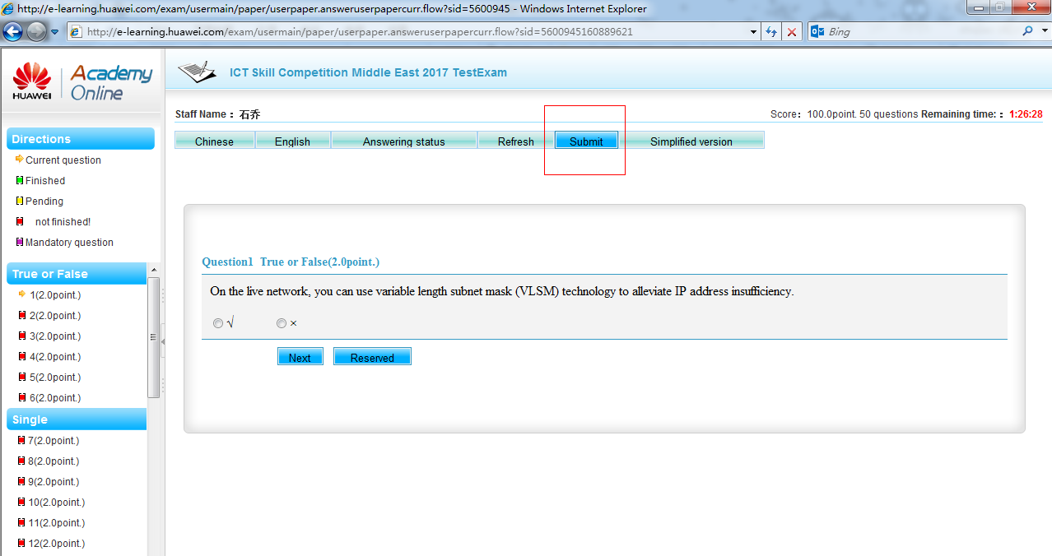
- Fill in the based-in verification code
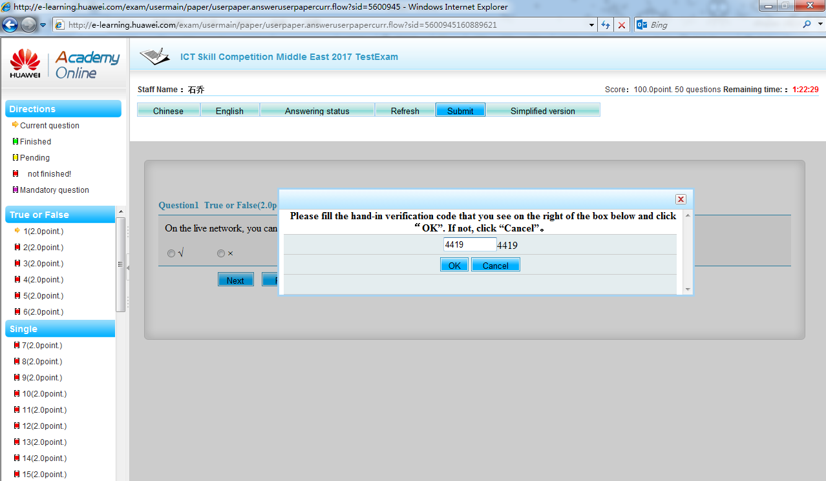
- Finish the exam and get your own score
